TASK 2
AWS EC2 WordPress Deployment
with Terraform

Umar Satti

Table of Contents
Task Objective 3
Architecture Diagram 3
WordPress Deployment on AWS 4
Task 1.1: Install Terraform on your local machine or in a development environment 4
Task 1.2: Configure AWS CLI with your credentials to allow Terraform to interact with your AWS account (on Windows) 4
Task 1.3: Create Terraform Project Structure 6
Task 1.4: Create S3 Bucket for Terraform Remote Backend 7
Task 1.5: Root Directory Files 8
Task 1.6: Configure VPC Module 13
Task 1.7: Configure EC2 Module 18
Task 1.8: Running Terraform Commands to Deploy Infrastructure 21
Task 1.9: Validate Infrastructure Deployment and WordPress Installation 24
Task 1.10: Troubleshooting and Lessons Learned 35
Conclusion 36

Task Objective
Provision an EC2 instance on AWS using Terraform, install WordPress, set up a MySQL database on the instance, and configure WordPress to use that MySQL database. This setup should utilize a user data script for automation.

Architecture Diagram
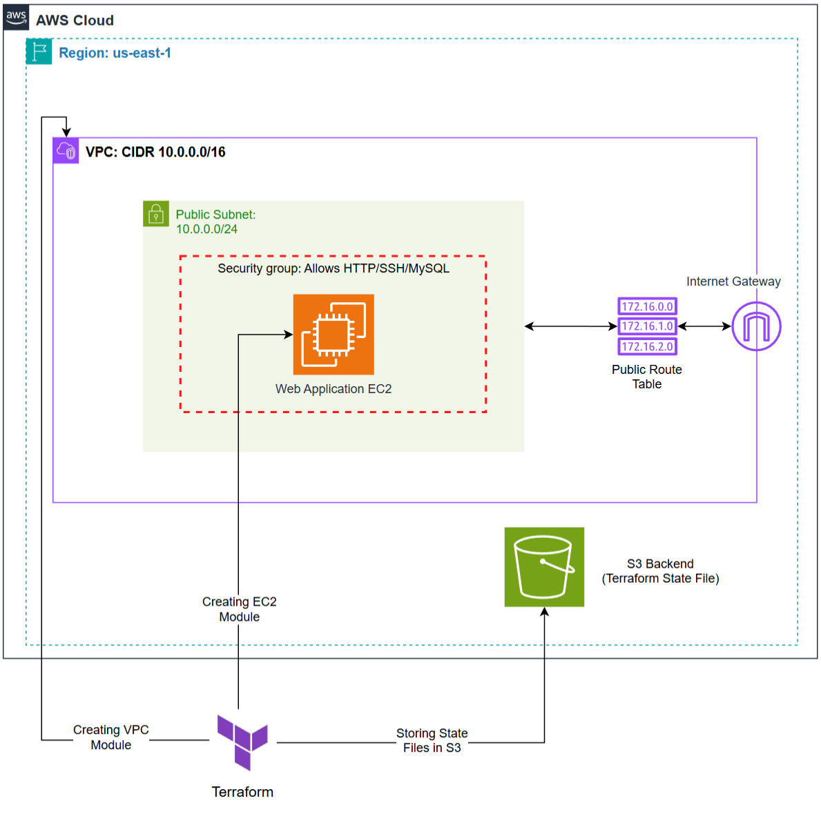

WordPress Deployment on AWS
This guide walks through step-by-step instructions for deploying a WordPress application using Terraform on AWS

Task 1.1: Install Terraform on your local machine or in a development environment
Steps:
- Navigate to HashiCorp official website to install the Terraform CLI for Windows (or any operating system). Link: https://developer.hashicorp.com/terraform/install
- Extract the terraform file and store it in the desired location. Note down the path as this is required later.
- Open “System Properties” and then click “Environment Variables” at the bottom of the tab.
- Navigate to the “user variables” and double-click or edit the “Path” option.
- Add the path that was noted in the second step i.e. “C://Terraform” as this folder contains the terraform.exe file.
- To verify if Terraform is functional, open a Command Prompt or PowerShell and type the following command: “terraform --version”.
- This command will display terraform version and operating system. Additionally, it also confirms that terraform is downloaded and accessible from local CLI.

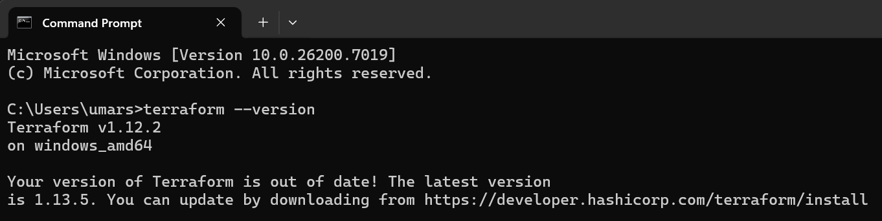

Task 1.2: Configure AWS CLI with your credentials to allow Terraform to interact with your AWS account (on Windows)
Steps:
- Download the AWS CLI MSI installer for Windows (64-bit) from the following link: https://awscli.amazonaws.com/AWSCLIV2.msi
- Run the AWS CLI installer by choosing custom path. Open “System Properties” and then click “Environment Variables” at the bottom of the tab.
- Navigate to the “user variables” and double-click or edit the “Path” option.
- Add the path that was noted in the second step as this folder contains the AWSCLIV2.msi file.
- Use “aws --version” to confirm that AWS CLI was successfully installed and the path was correctly configured.
- Use “aws configure” command and input the AWS account credentials.
- Enter the AWS Access Key ID, AWS Secret Access Key, Default region name, and Default output format.
Note: I downloaded AWS CLI from the official AWS documentation page and then added this C:\Users\umars\Downloads\AWSCLIV2.msi path in the environment variables. To confirm that AWS CLI was properly installed, I used the command “aws --version” which displays the aws-cli version 2.22.7.
I also configured AWS CLI using my personal AWS account credentials:
- Access Key ID: ending with SP5P
- Secret Access Key: ending with MrgY
- Default region: us-east-1
- Output format: Default (JSON)

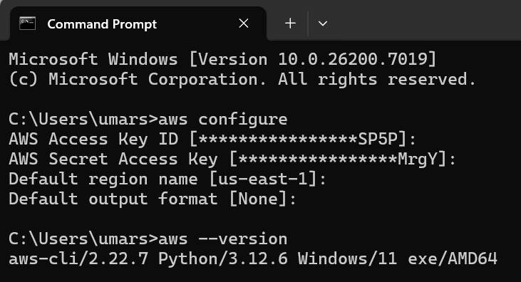

Task 1.3: Create Terraform Project Structure
Steps:
- Create a provider.tf (or terraform.tf) file in the root directory. This file defines the AWS provider, provider version, AWS region, and the S3 backend for storing Terraform state files.
- Create an S3 bucket in the same AWS region to store Terraform state files (explained in Task 1.4 below).
- Create a main.tf file in the root directory. This connects modules together, passes outputs from the VPC module to the EC2 module, and passes variables between them.
- Create a variables.tf file in the root directory. This file defines default values (key-value pairs) for parameters such as VPC name, CIDR block, EC2 AMI ID, and instance type.
- Create an outputs.tf file in the root directory. This file exposes important module outputs such as EC2 public IP and public DNS after deployment.
- Create a modules directory that contains two submodules i.e. vpc and ec2. Each submodule contains its own main.tf, variables.tf, and outputs.tf files.
- Create a user data bash script (userdata.sh) either in the root directory or inside the EC2 module. This script automates WordPress setup by installing Apache, PHP, MySQL, creating a database, and configuring WordPress automatically on instance boot.
The terraform project directory structure should look like this:
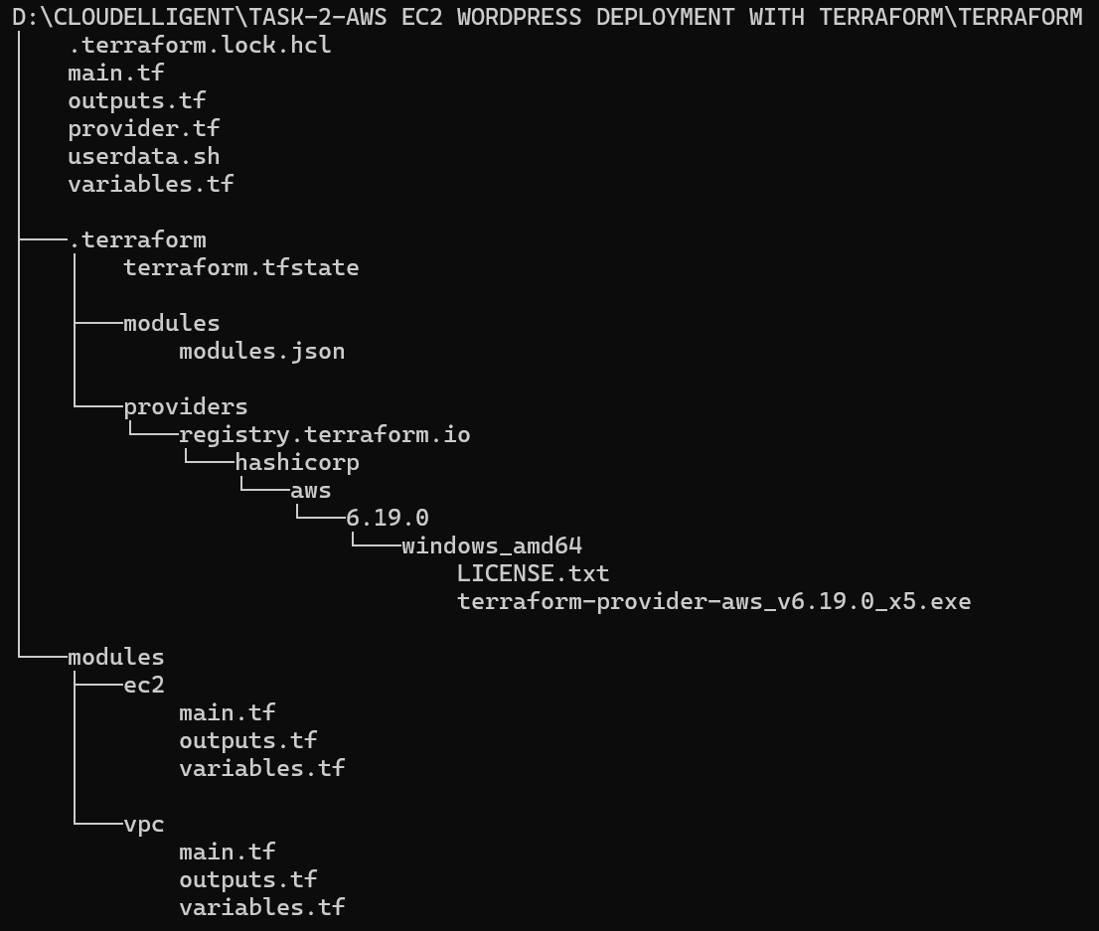

Task 1.4: Create S3 Bucket for Terraform Remote Backend
Steps:
- Log in to the AWS Management Console. Navigation to S3 using the search bar at the top.
- Click on Create Bucket button.
- Choose General Purpose, add a globally unique bucket name, and make sure the AWS Region is the same as Terraform.
- Click Create Bucket.
- Update provider.tf or terraform.tf file in root directory to reference this S3 bucket in the backend block.
Once the S3 bucket is created in the AWS Management Console and referenced in the Terraform backend configuration, Terraform automatically begins storing and versioning state files in this bucket.
In this case, the S3 bucket named umarsatti-terraform-state-file-s3-bucket is used as the remote backend, as defined in the provider.tf file. The backend block ensures all state information is centralized, secure, and persistent across multiple users or workstations.
The screenshot you included shows the exact file path inside your S3 bucket:
S3 > Buckets > umarsatti-terraform-state-file-s3-bucket > task2 > terraform.tfstate
This confirms that:
- Terraform successfully initialized the backend and wrote the state file to the S3 bucket.
- The terraform.tfstate file contains metadata about all deployed AWS resources (VPC, Subnet, EC2, etc.).
- Every terraform plan, apply, or destroy operation reads and updates this file automatically.
- The locking mechanism (enabled by use_lockfile = true) ensures that no two processes modify the state simultaneously, preventing state corruption.

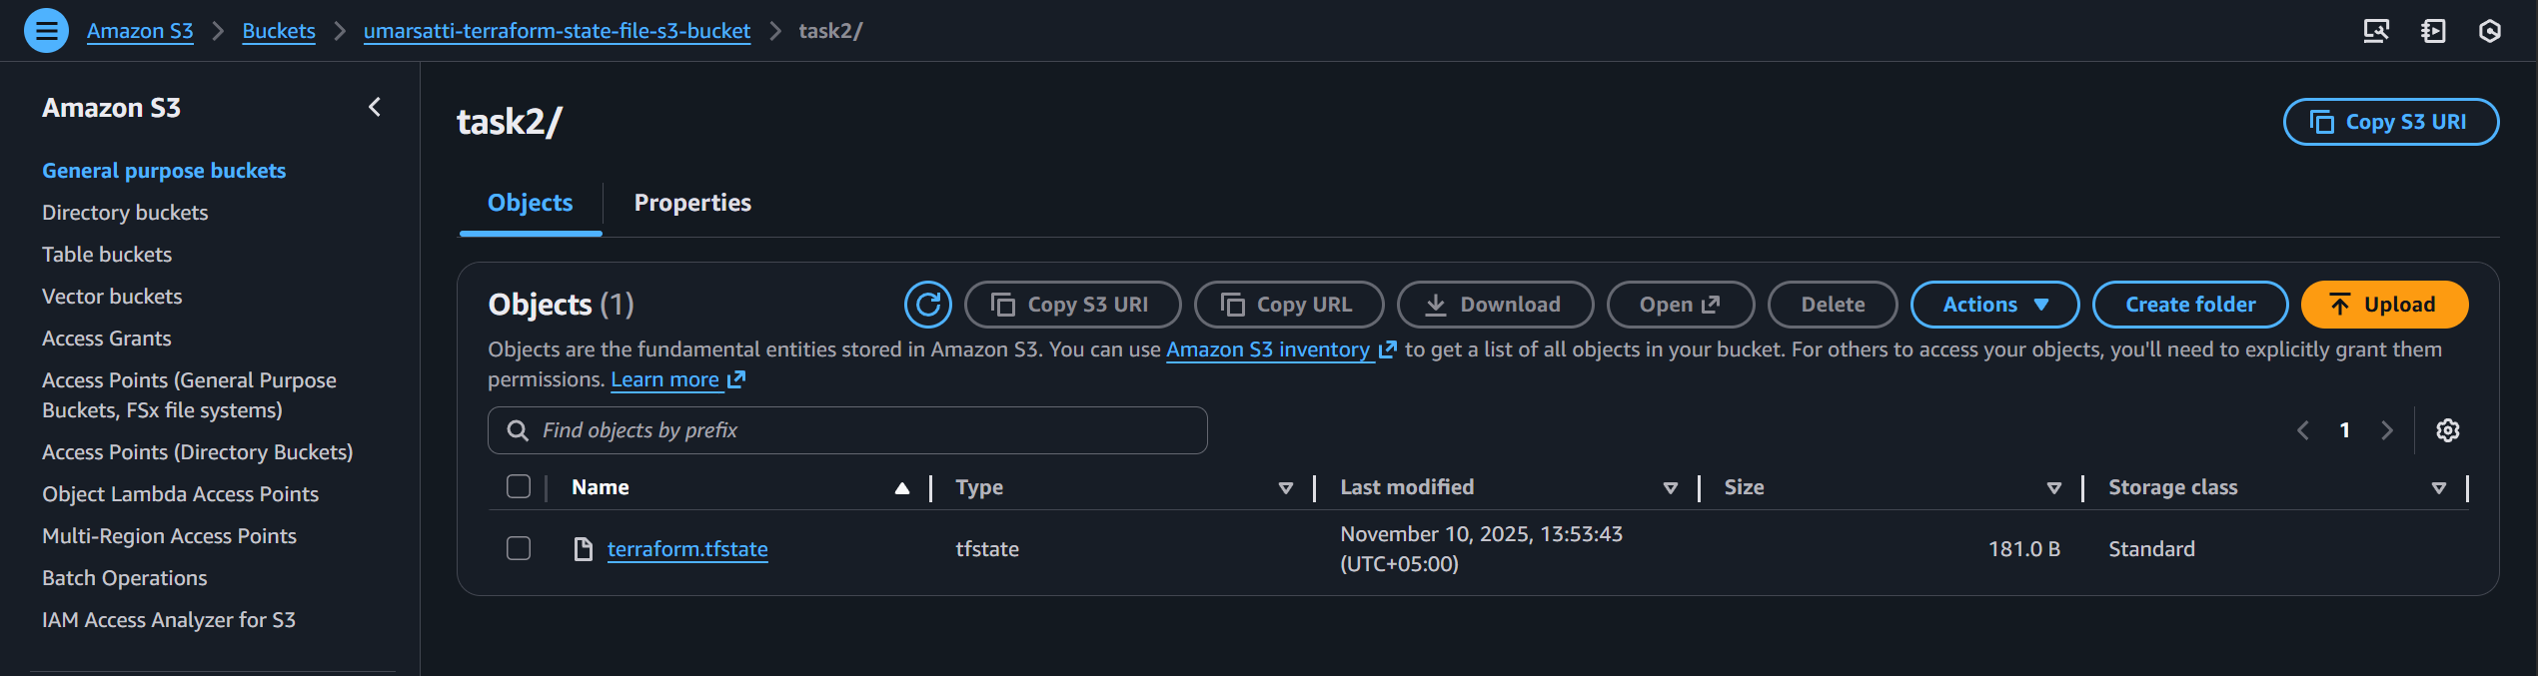

Task 1.5: Root Directory Files
This section explains each Terraform configuration file located in the project’s root directory and their purpose in connecting the VPC and EC2 modules.
provider.tf:
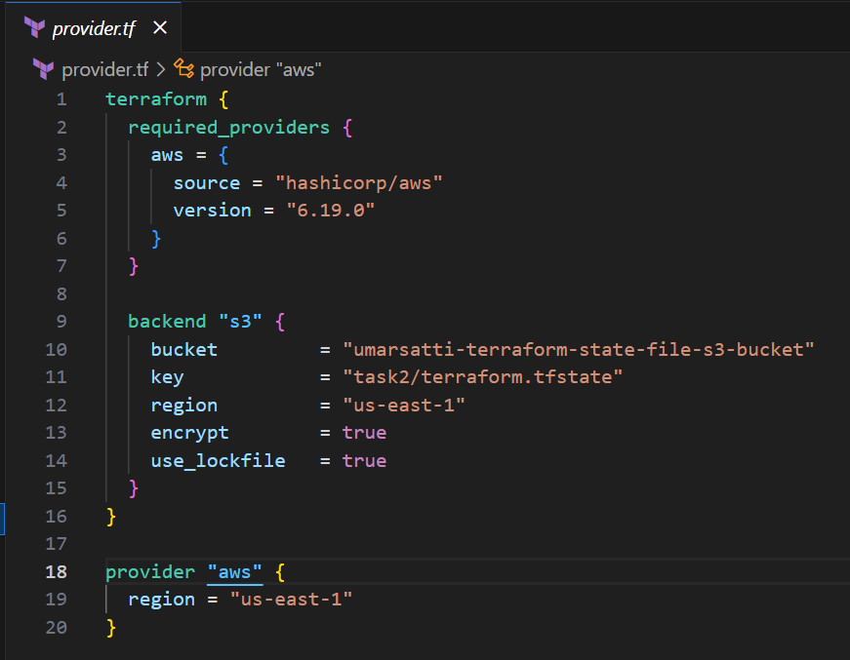

This file defines the AWS provider configuration and the remote backend for storing the Terraform state file securely in an Amazon S3 bucket.
- The terraform block specifies that this project uses the AWS provider sourced from HashiCorp, version 6.19.0.
- The backend "s3" configuration ensures that the Terraform state file (terraform.tfstate) is stored in an S3 bucket named umarsatti-terraform-state-file-s3-bucket under the path task2/terraform.tfstate.
- State file encryption is enabled, and use_lockfile = true prevents multiple users from updating the state simultaneously.
- The provider "aws" block defines the AWS region (us-east-1) where all infrastructure resources will be created.
Using a remote backend improves collaboration and ensures the state file is safe even if the local environment changes.

main.tf:
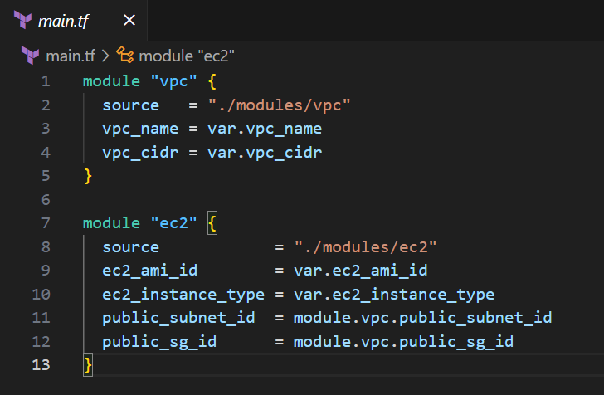
This file defines how Terraform composes the overall infrastructure using modules for networking and compute layers.
- The VPC module (./modules/vpc) provisions all networking components including VPC, subnets, internet gateway, route tables, and security groups. The variables vpc_name and vpc_cidr are passed from the root level variables file.
- The EC2 module (./modules/ec2) provisions an EC2 instance that hosts WordPress. It references the subnet ID and security group ID outputs from the VPC module (module.vpc.public_subnet_id and module.vpc.public_sg_id) to ensure proper network placement.
This modular structure promotes reusability and clean separation of concerns, where each module handles a specific AWS service.

variables.tf:
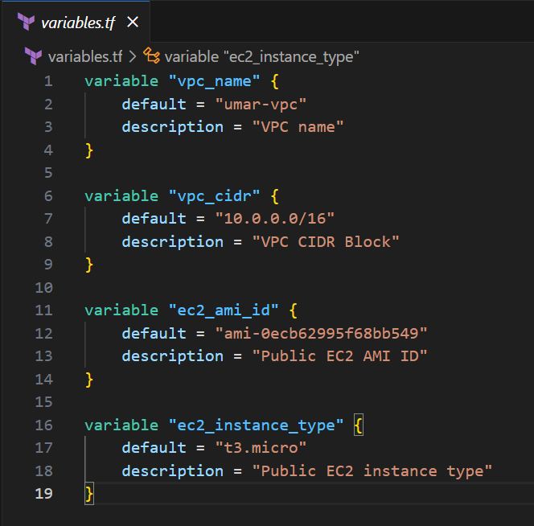

This file defines the input variables for the Terraform project.
- vpc_name and vpc_cidr are used by the VPC module to define the VPC name and IPv4 CIDR range.
- ec2_ami_id specifies the Amazon Machine Image used to create the EC2 instance. This is an Ubuntu AMI.
- ec2_instance_type defines the compute capacity of the instance. A t3.micro is used for this task.

outputs.tf:
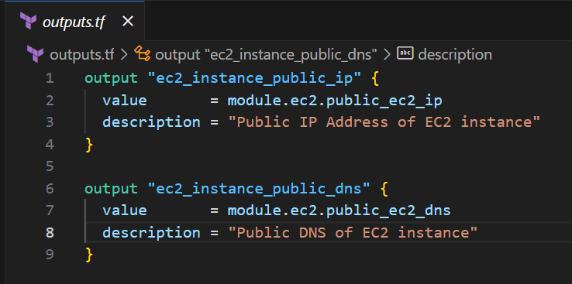
The outputs file displays key information about deployed resources after a successful terraform apply execution.
- ec2_instance_public_ip outputs the public IP address of the EC2 instance, allowing direct access to the WordPress application.
- ec2_instance_public_dns outputs the public DNS name of the EC2 instance, which can also be used to access WordPress in a browser.

userdata.sh (User Data script):
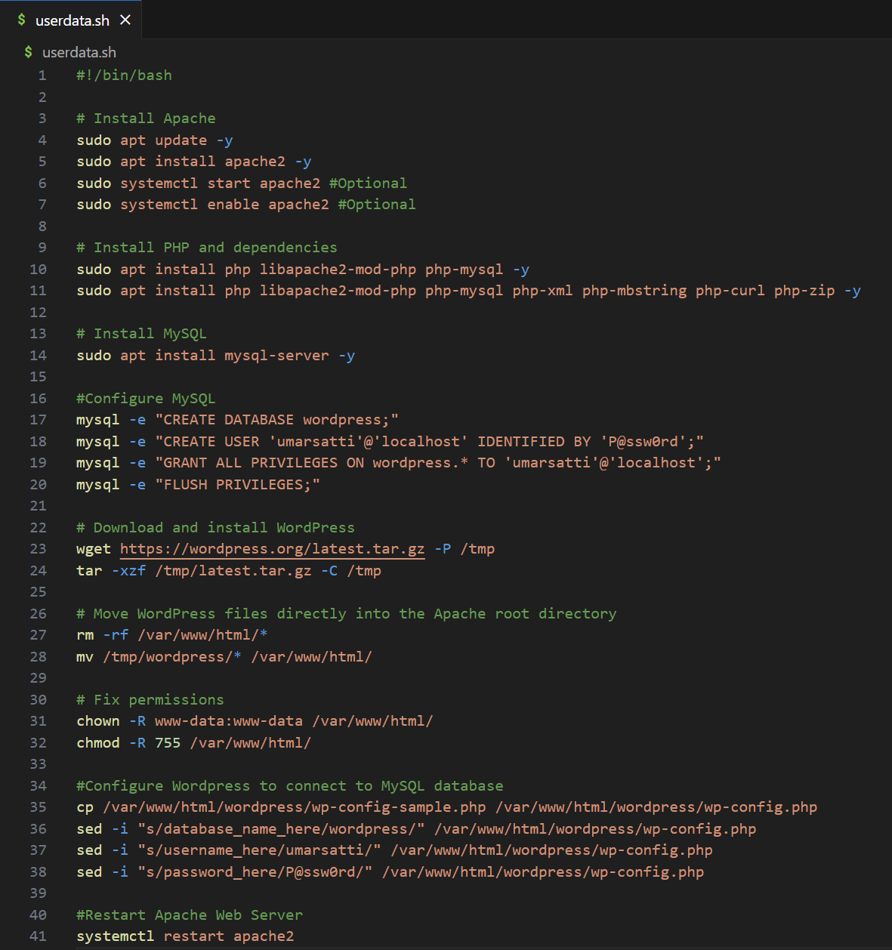

This user data script automates the deployment and configuration of the WordPress environment on the EC2 instance at startup.
- Installs and starts the Apache web server and PHP with all required extensions for WordPress.
- Installs MySQL server, creates a wordpress database, and sets up a dedicated user named umarsatti with full privileges.
- Downloads and extracts the latest version of WordPress, sets file permissions, and configures database credentials in wp-config.php.
This automation ensures a fully functional WordPress site is ready immediately after the EC2 instance is launched.

Task 1.6: Configure VPC Module
This section explains each Terraform configuration file located in the VPC modules (modules/vpc) directory.
main.tf:
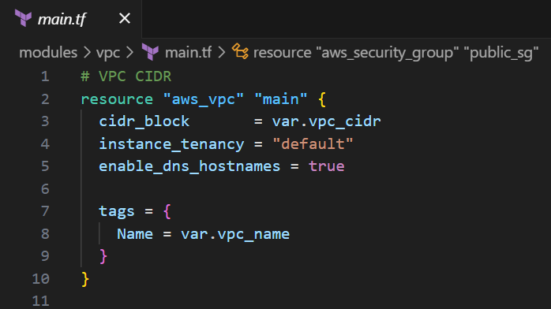
This block defines the VPC networking environment.
- The cidr_block value is dynamically passed from the variables.tf file
- enable_dns_hostnames = true ensures that instances within the VPC automatically receive DNS hostnames
- The VPC is tagged with a dynamic name (var.vpc_name) for better visibility and resource management inside AWS.

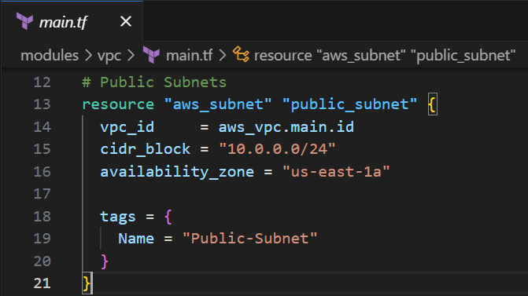
This block creates a public subnet within the previously defined VPC.
- The subnet uses the CIDR block 10.0.0.0/24
- It resides in the us-east-1a Availability Zone
- The vpc_id references the VPC created earlier, ensuring proper network association.
- Name of this subnet (using tags) is “Public-Subnet”.

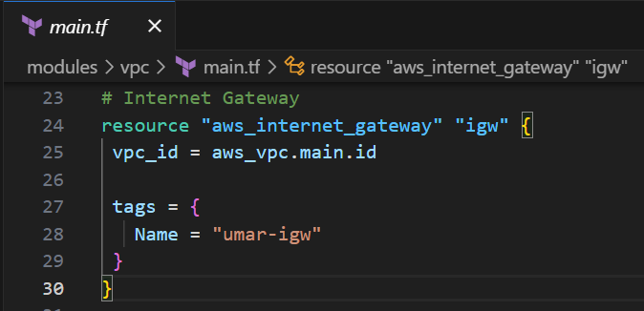
This block provisions an Internet Gateway (IGW) and attaches it to the VPC.
- The IGW enables instances in the public subnet to communicate with the internet.
- The vpc_id interpolation ties the IGW to the specific VPC, ensuring connectivity.
- Tagged as “umar-igw” for easy identification.

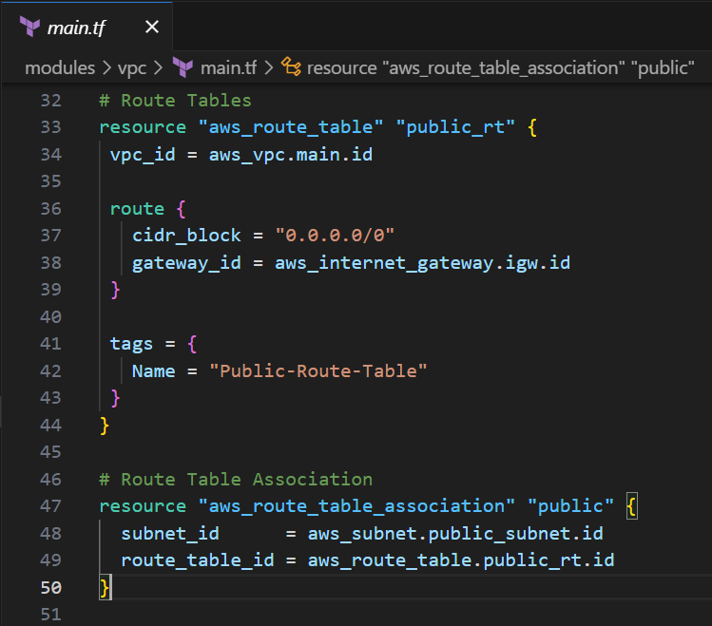
This section sets up routing for the public subnet:
- The Route Table directs all outbound traffic (0.0.0.0/0) through the Internet Gateway, enabling external connectivity.
- The Route Table Association binds the “Public-Subnet” to this route table, ensuring that all instances in that subnet use the IGW for internet access.
- This is a fundamental step to make EC2 instances publicly reachable.

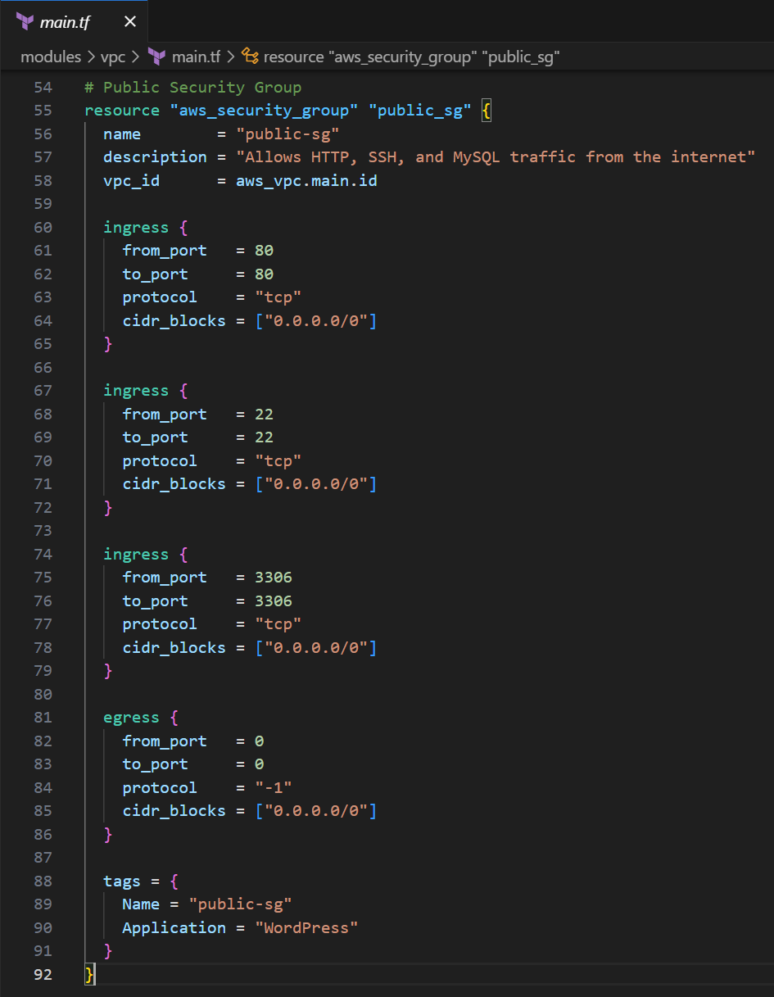
This block defines the Security Group for the public EC2 instance.
- It allows inbound connections on:
  - Port 22 (SSH) for secure remote access.
  - Port 80 (HTTP) for WordPress website access.
  - Port 3306 (MySQL) for database communication.
- Outbound traffic is unrestricted, allowing the instance to reach external services.
- The security group is tagged with the name “public-sg”.

variables.tf:
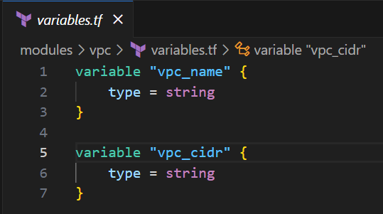
These variables parameterize the VPC configuration:
- vpc_name allows the VPC name to be dynamically set
- vpc_cidr defines the CIDR block (e.g., 10.0.0.0/16) used for the VPC network.

outputs.tf:
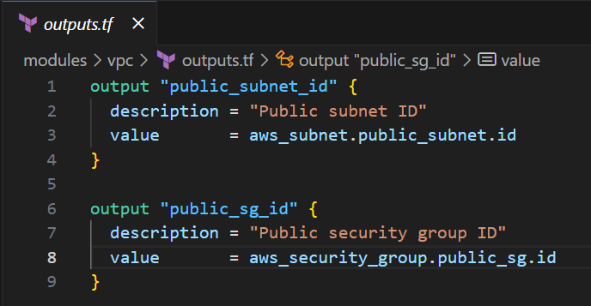
Outputs make key resource identifiers available to other modules (like EC2).
- public_subnet_id exposes the subnet’s ID so it can be referenced by the EC2 instance.
- public_sg_id makes the security group ID accessible to other resources.
This is how the VPC module integrates with the EC2 module.

Task 1.7: Configure EC2 Module
This section explains each Terraform configuration file located in the EC2 modules (/modules/ec2) directory.
main.tf:
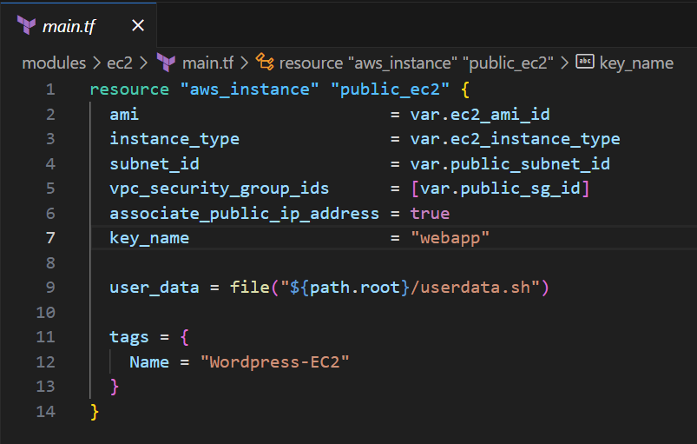
This block provisions an EC2 instance that will host the WordPress application.
- Uses variables for AMI ID and instance type.
- The instance launches within the Public Subnet and is associated with the Public Security Group from the VPC module.
- associate_public_ip_address = true ensures that the instance receives a public IP, making it accessible over the internet.
- The user_data script automates installation and setup of Apache, PHP, MySQL, and WordPress on startup.
- The EC2 instance is tagged as “Wordpress-EC2” for easy identification.

variables.tf:
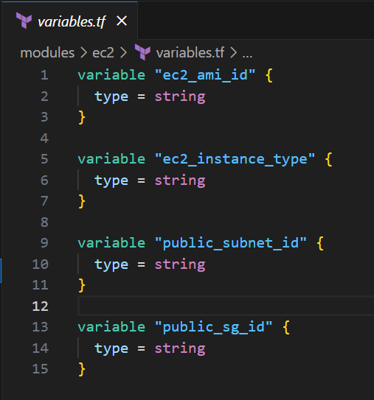
These variables define parameters required for EC2 deployment:
- ec2_ami_id specifies the AMI image used for instance creation.
- ec2_instance_type controls the instance’s compute capacity.
- public_subnet_id and public_sg_id inherit values from the VPC module outputs, enabling proper network placement and security configuration.

outputs.tf:
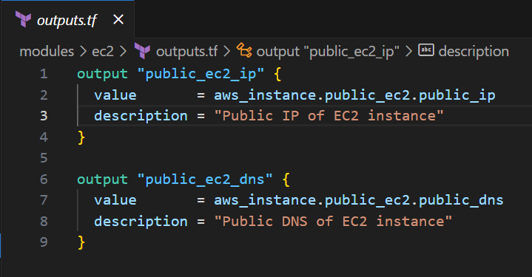
These outputs expose connection details of the deployed EC2 instance:
- public_ec2_ip displays the instance’s public IP address for direct access.
- public_ec2_dns provides the public DNS name, which can be used to access WordPress via a browser.
- These outputs make it easy to verify and connect to the running instance after terraform apply.

Task 1.8: Running Terraform Commands to Deploy Infrastructure
This section documents the series of Terraform CLI commands executed to deploy, validate, and destroy the WordPress environment.
Note: To perform this task, the user must be in the root directory of Terraform project where the provider.tf and the root main.tf files are stored.

Step 1: terraform init
Initializes the working directory by downloading the required provider plugins and connecting them to the configured backend (S3).
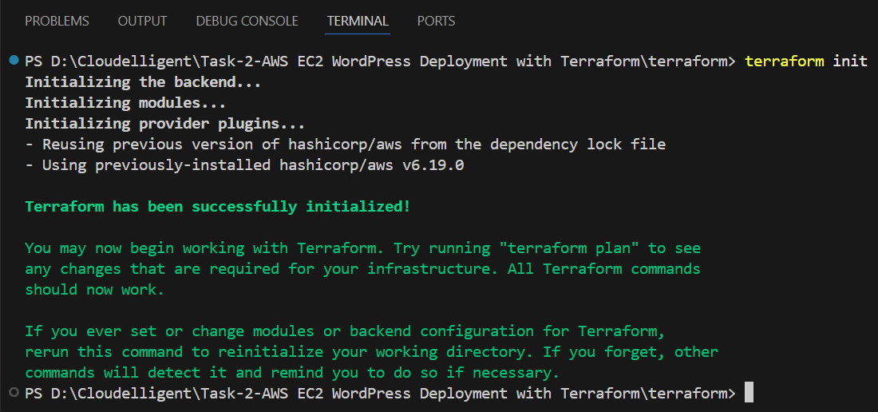
By running this command, Terraform confirms initialization, backend setup, and provider readiness.

Step 2: terraform validate
Performs a syntax and logic check on all configuration files in the directory. Outputs an error if the logic or syntax is incorrect.
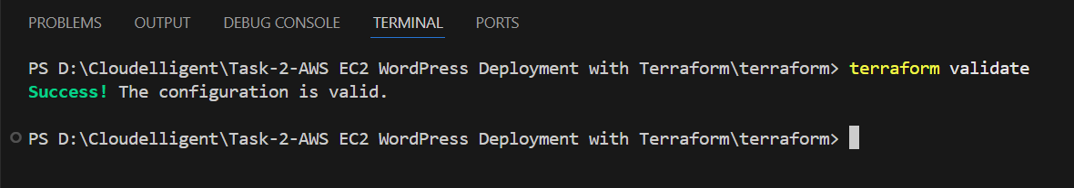

Step 3: terraform plan
Generates an execution plan showing all actions Terraform will perform to reach the desired state (resource creation, updates, or deletions).
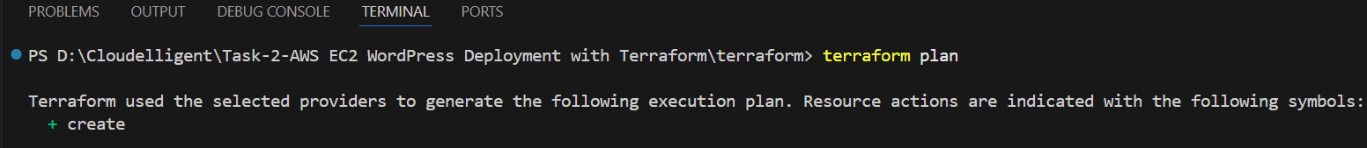
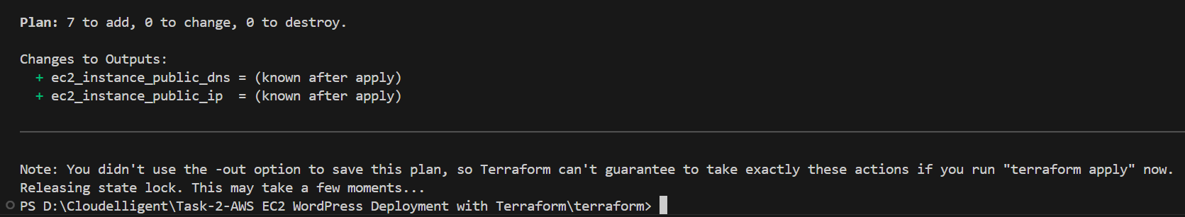
Plan shows 7 to add, 0 to change, 0 to destroy, confirming all required AWS resources are queued for creation.

Step 4: terraform apply –auto-approve (terraform apply)
Executes the plan and provisions the resources defined in the Terraform configuration without manual confirmation.
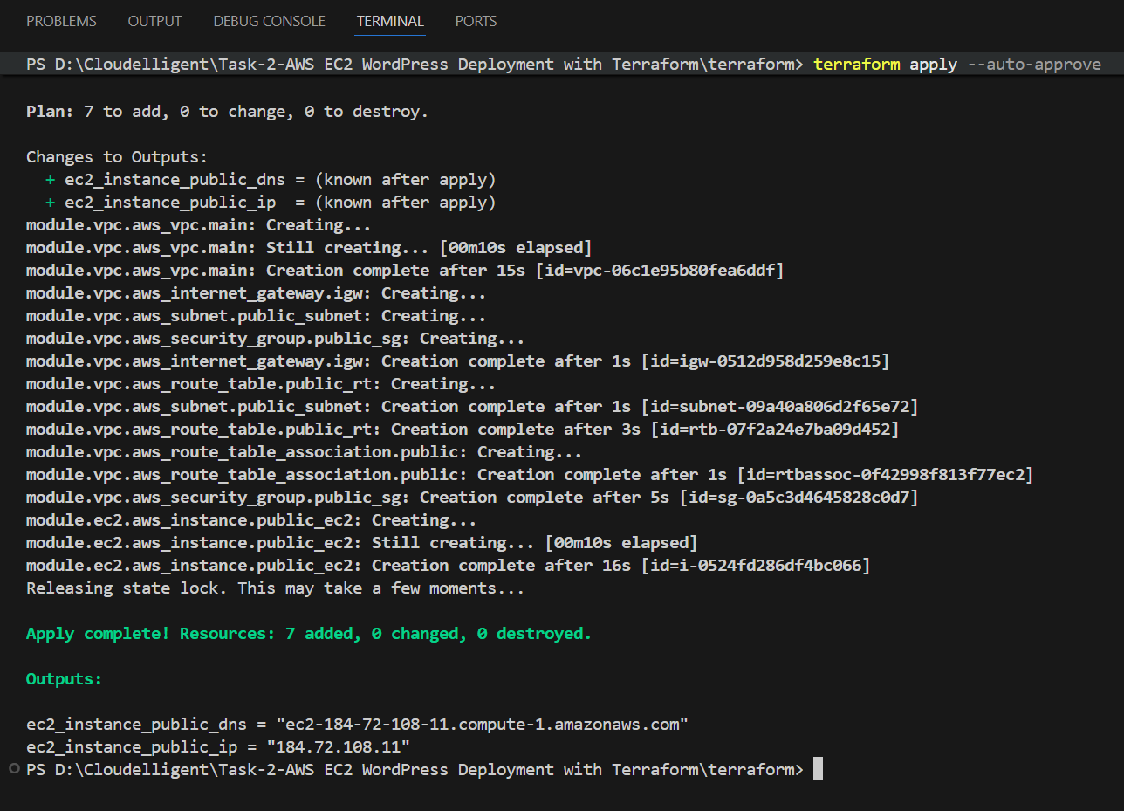
Resources (VPC, Subnet, Security Group, EC2, etc.) are created successfully, followed by public IP and DNS outputs for WordPress instance. Additionally, the user can open their browser and navigate to the EC2 Public IP/DNS to view the live WordPress site.

Step 5: terraform destroy --auto-approve (or terraform destroy)
Destroys all resources previously created by Terraform, cleaning up the AWS environment.
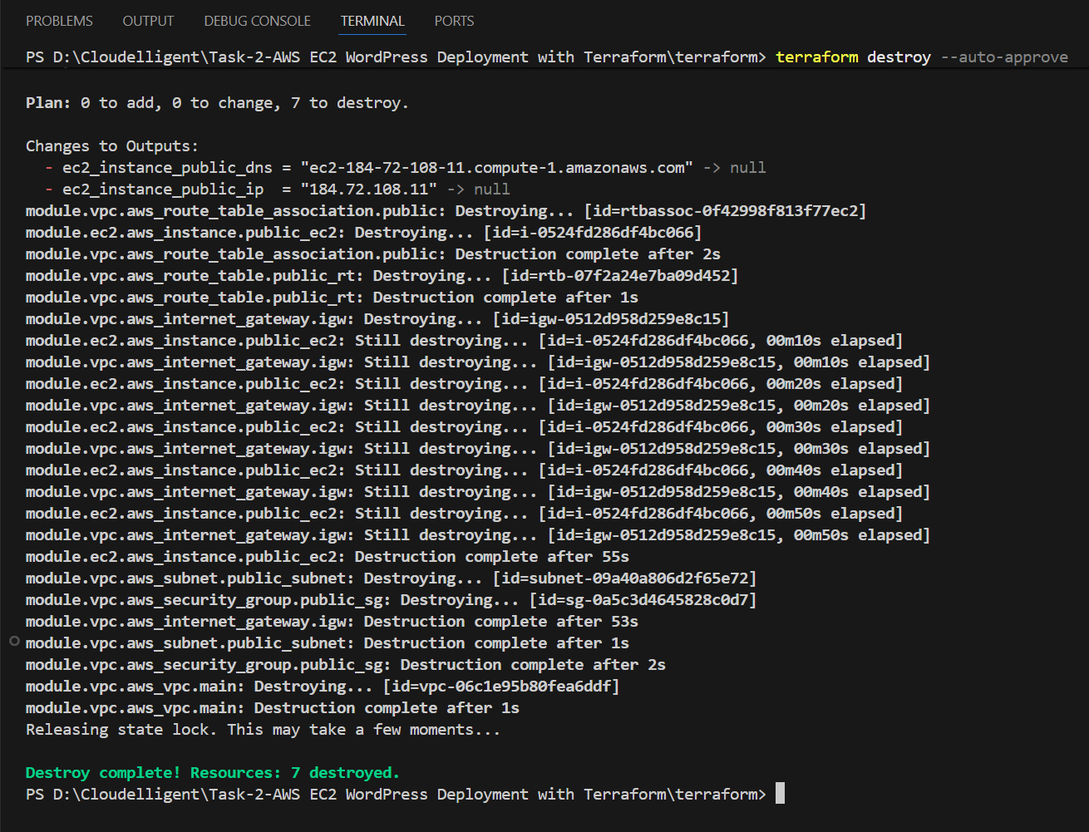
Displays Plan: 0 to add, 0 to change, 7 to destroy and confirm complete deletion of all deployed resources.
The state file in S3 will also be updated automatically to reflect the destroyed state.

Task 1.9: Validate Infrastructure Deployment and WordPress Installation
This task demonstrates the successful deployment and verification of all AWS and application-level components created using Terraform. It includes screenshots of the AWS infrastructure, validation commands from the EC2 instance, and the full WordPress installation process.
Step 1: Verify Deployed AWS Infrastructure
After running terraform apply command, Terraform provisions all the required networking and compute resources. In this step, please confirm that these resources exist and are configured correctly.
Verify VPC Creation
- Sign in to the AWS Management Console.
- Navigate to VPC service using the search bar at the top and then click Your VPCs.
- Verify that a VPC named umar-vpc has been created.
- CIDR Block: 10.0.0.0/16
- DNS Hostnames: Enabled
- This VPC acts as the isolated network for your WordPress environment.
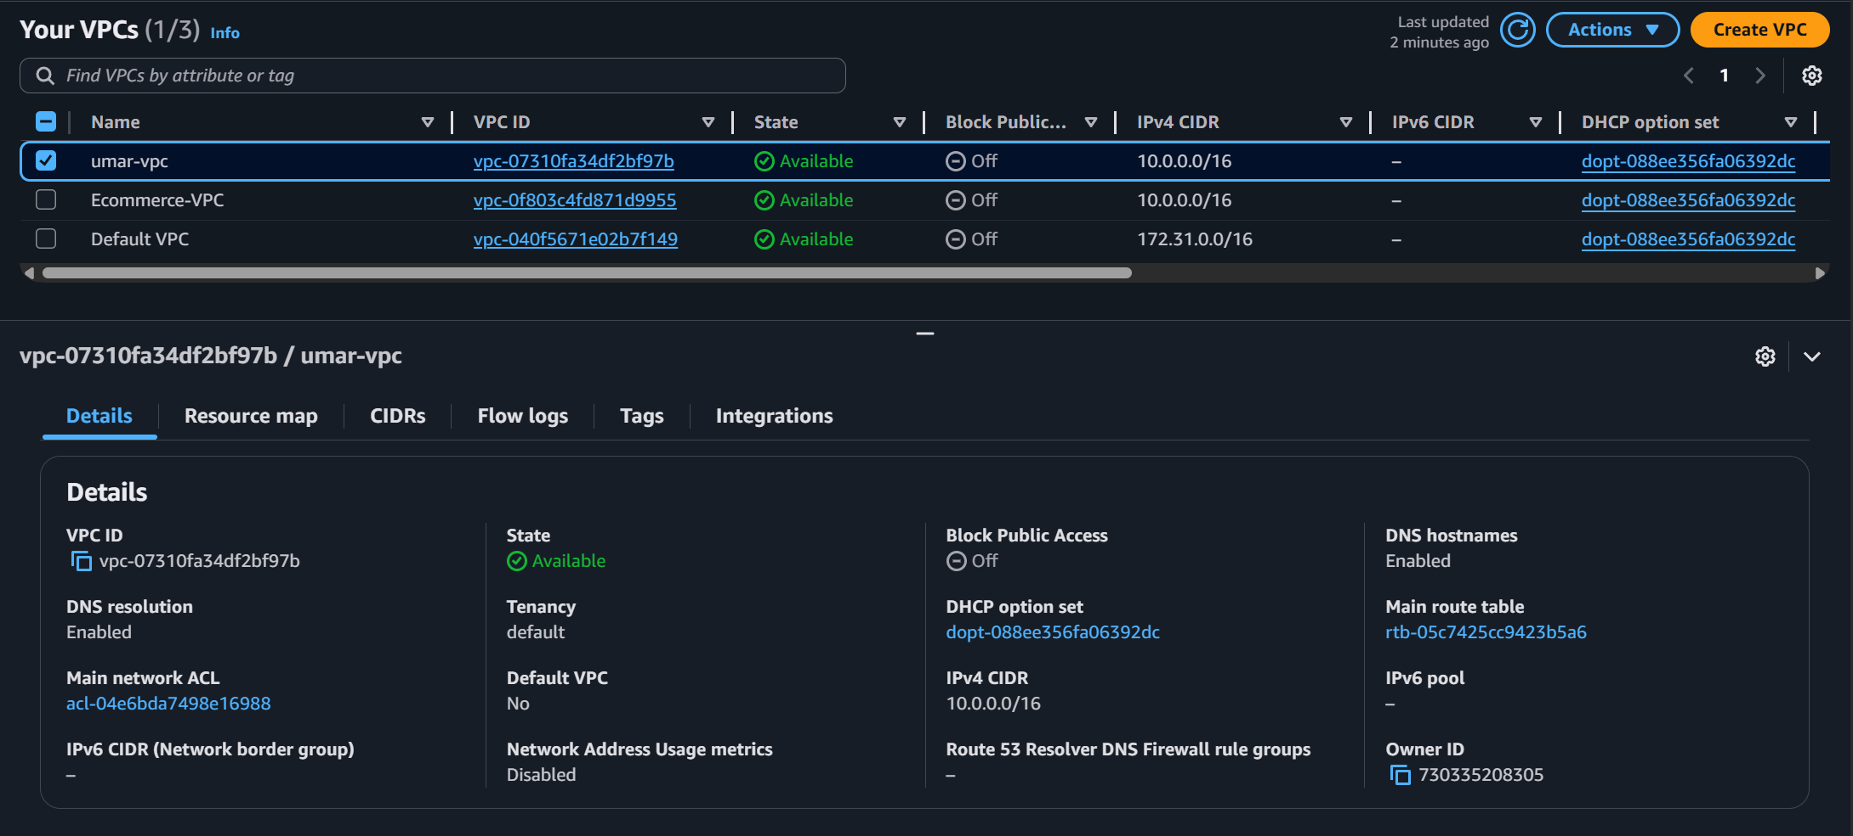
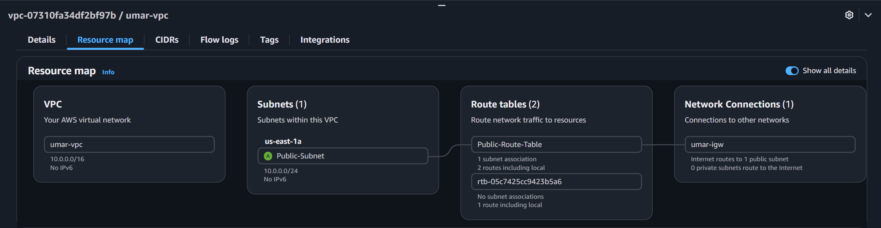
Verify Internet Gateway (IGW) Creation
- In the VPC console, choose Internet Gateways.
- Confirm that an Internet Gateway named umar-igw exists and is attached to your VPC. This gateway allows the EC2 instance to communicate with the internet.
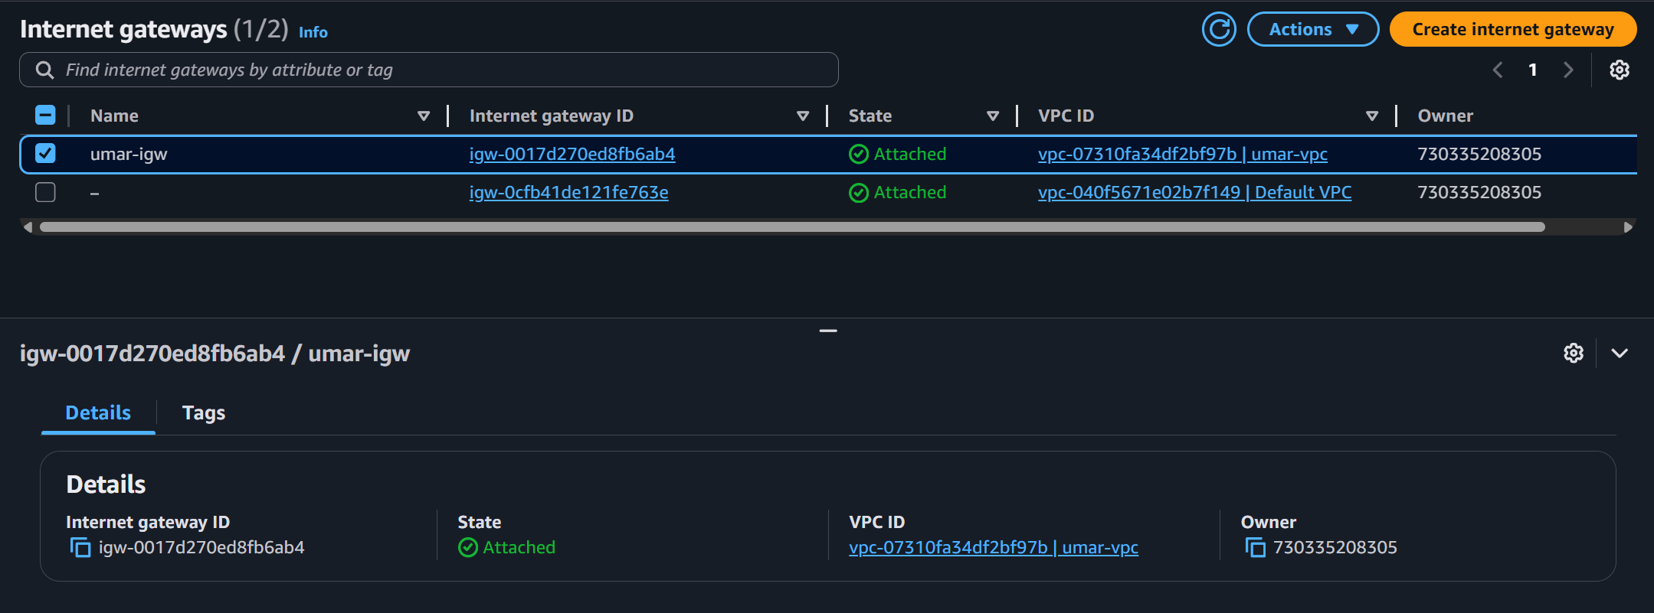

Verify Subnet Creation
- In the VPC console, choose Subnets located on the left navigation panel.
- Confirm that a Subnet named Public-Subnet exists with the IPv4 CIDR 10.0.0.0/24 and the same VPC ID (example: vpc-07310fa34df2bf97b).

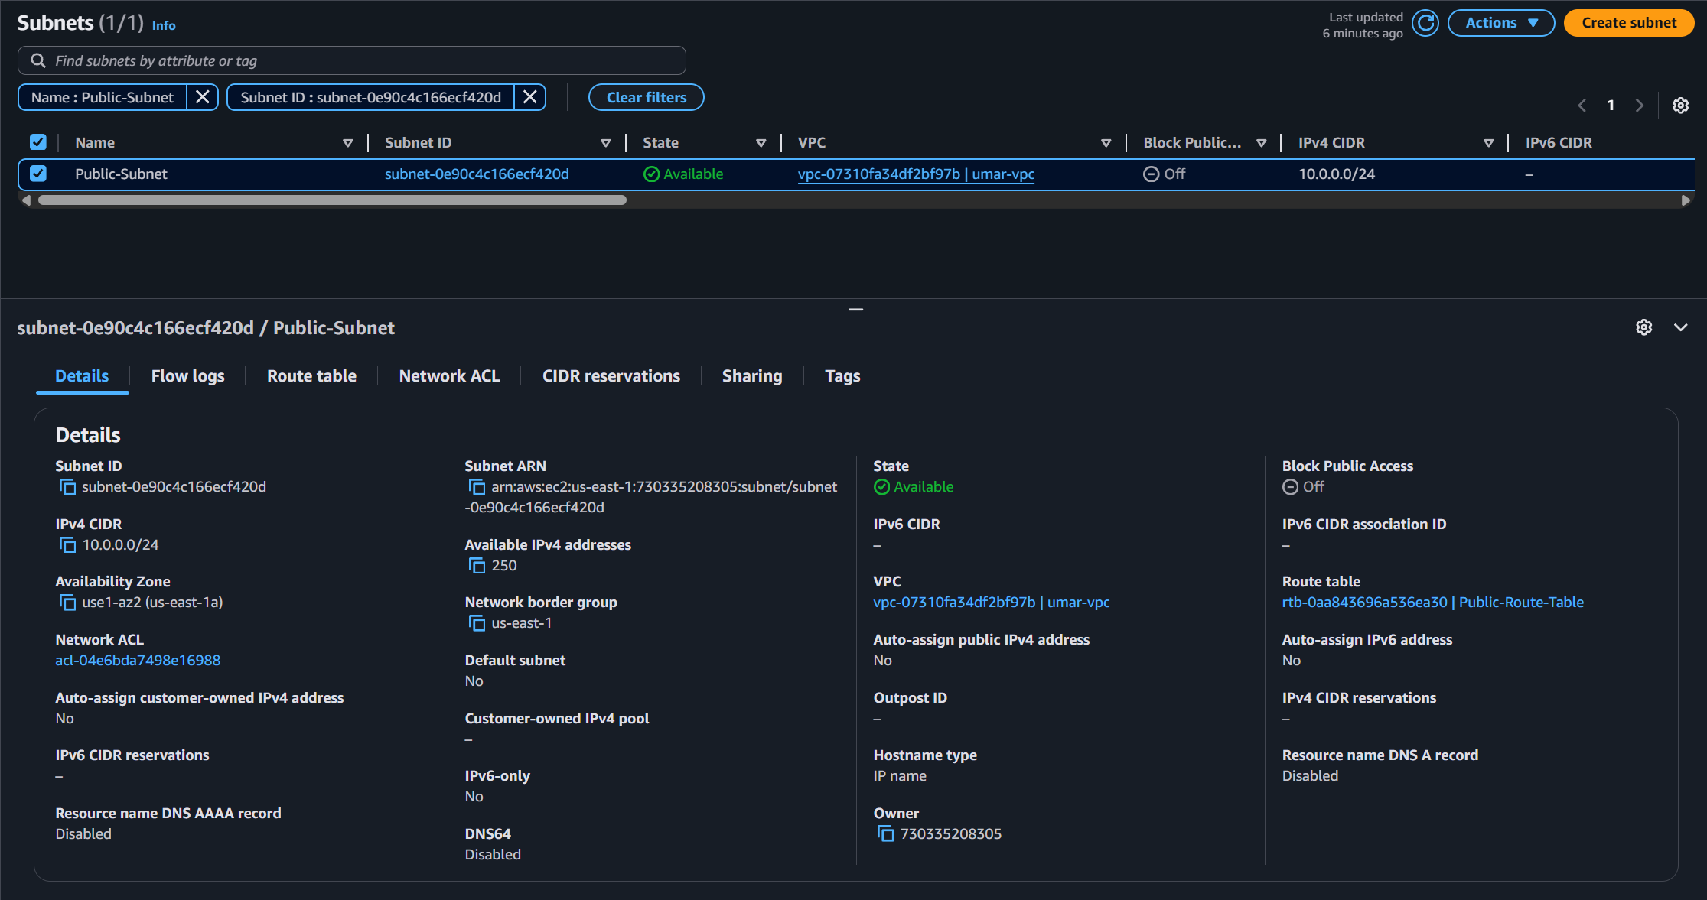

Verify Route Table and Routes Creation
- In the VPC console, choose Route tables located on the left navigation panel.
- Select the route table named Public-Route-Table.
- Check that it contains a route to the Internet Gateway with the destination 0.0.0.0/0.
- Under Subnet Associations, verify that the Public Subnet is associated with this route table as shown under Explicit subnet associations (1).

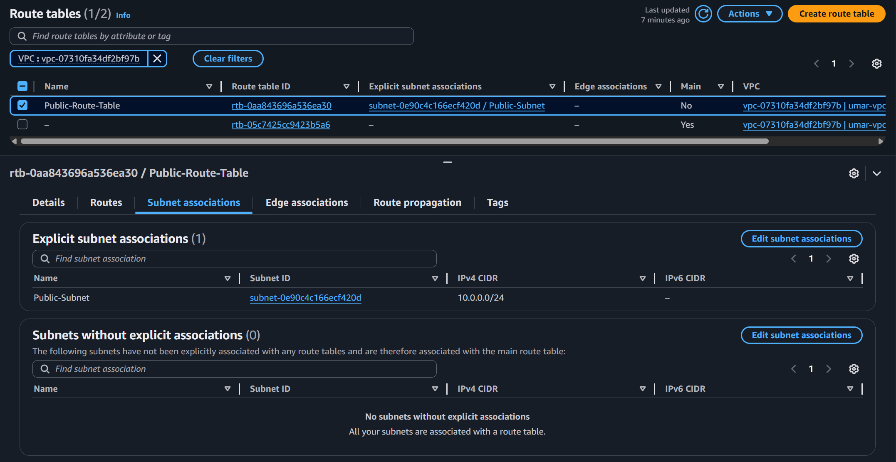
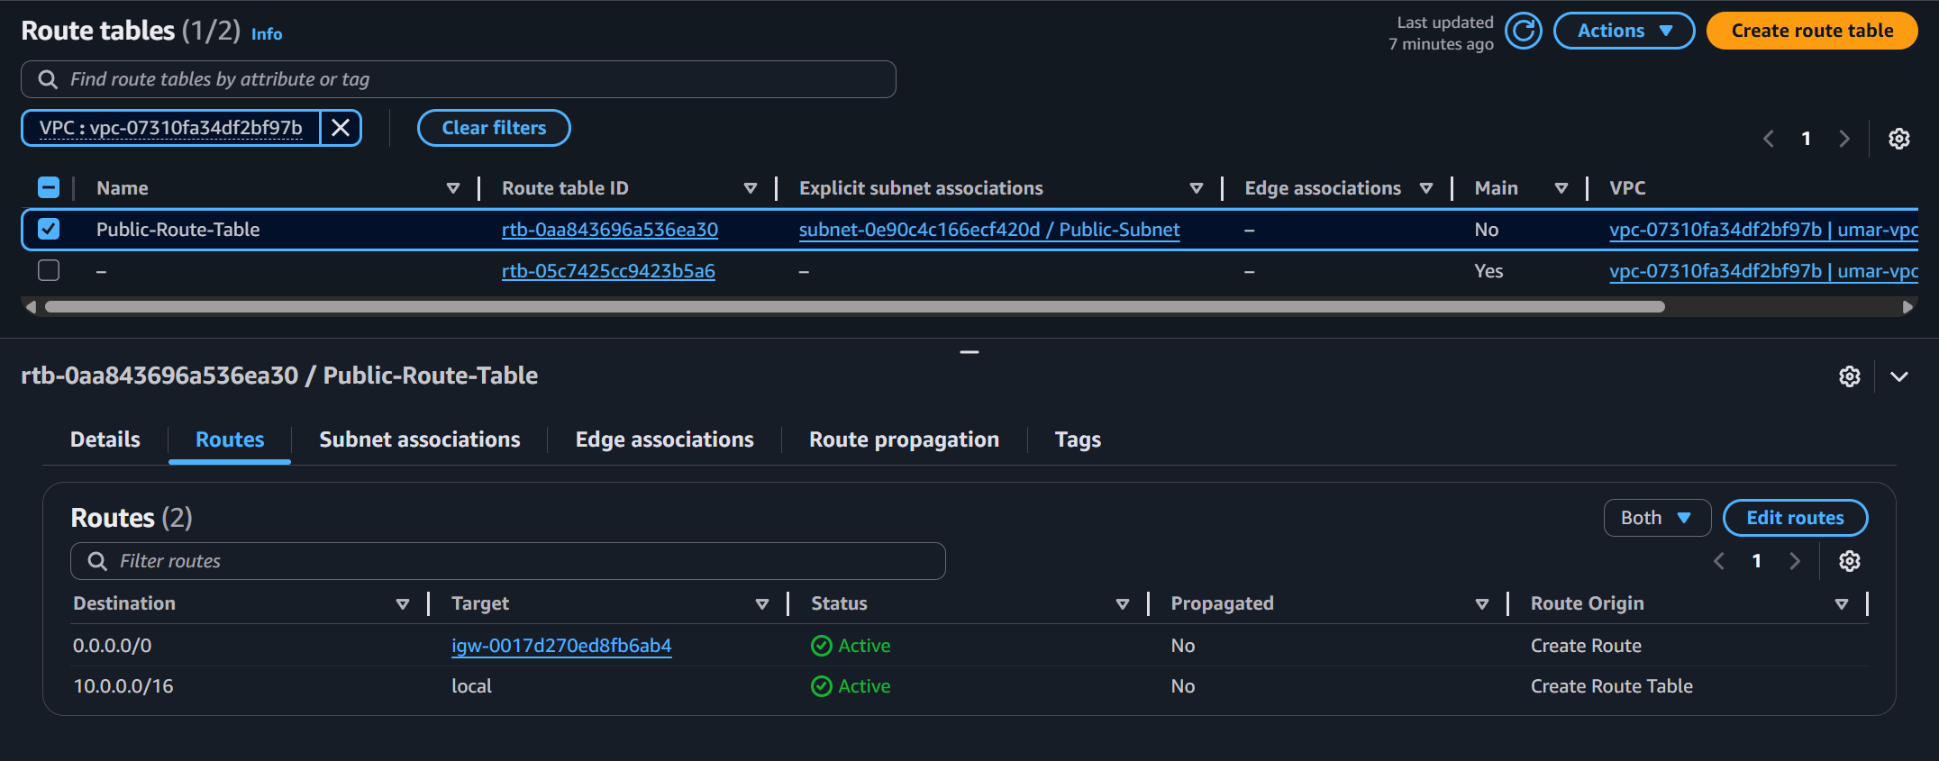

Verify Security Group Creation
- In the VPC console, choose Security groups located on the left navigation panel.
- Locate the public-sg security group
- It should have the following inbound rules:
Type | Protocol | Port range | Source
HTTP | TCP | 80 | 0.0.0.0/0
SSH | TCP | 22 | 0.0.0.0/0
MySQL/Aurora | TCP | 3306 | 0.0.0.0/0
4. Outbound rules should allow all traffic.

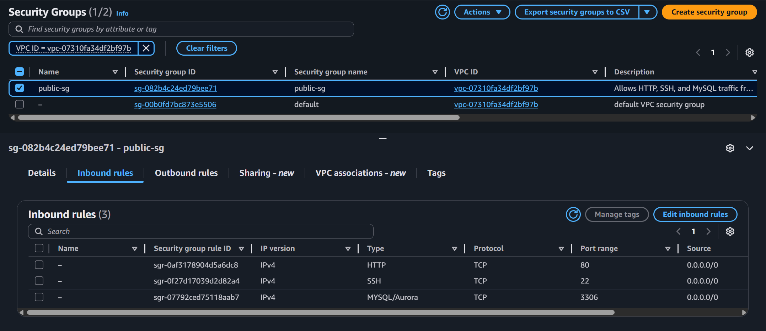

At this point, your VPC, Internet Gateway, subnet, route table, routes and security group are confirmed as functional.

Step 2: Verify EC2 Instance Deployment
Next, verify that Terraform successfully created the EC2 instance and that it is running.
To verify EC2 deployment status
- In the AWS Console, open EC2 service using the search bar and click Instances located on the left navigation panel.
- Confirm that an instance named WordPress-EC2 is in the Running state.
- Instance Type: t3.micro
- AMI: Ubuntu Server 24.04
- Subnet: Public-Subnet
- Public IP: Automatically assigned (example: 34.203.40.26)
This instance hosts the WordPress website.
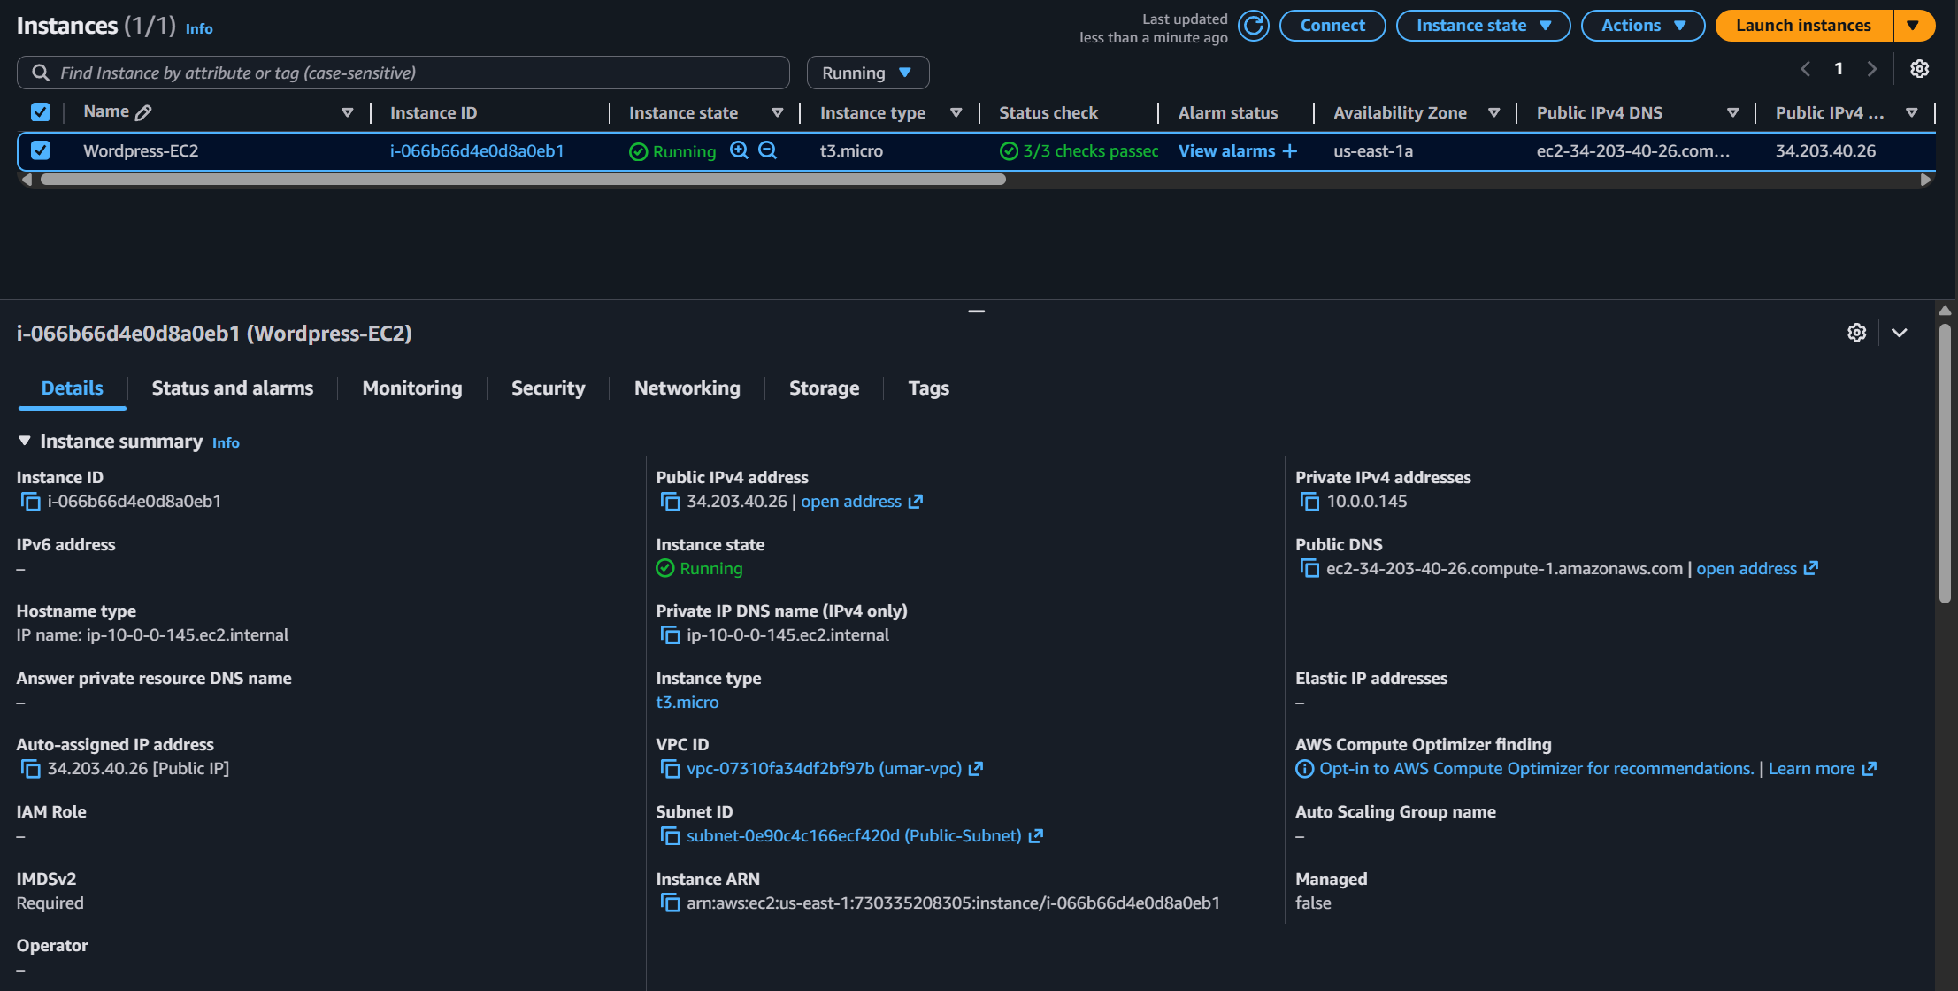

Step 3: Verify Services Running on the EC2 Instance
Terraform’s user data script automatically installs Apache, PHP, and MySQL during instance boot. The next step is to SSH into the EC2 instance and verify that all services are running.
Connect to EC2 Instance
- For this to work, it is important to have the key pair saved on local machine.
- Make sure the key pair (.pem file) has necessary permission. If not, run “chmod 400 <keypair.pem>
- Once that is done, use the following command to SSH into the instance:
- ssh -i “webapp.pem” ubuntu@<your-ec2-public-ip>
- Example: ssh -i “webapp.pem” ubuntu@ 34.203.40.26
- Once connected to the instance, verify that the Apache, PHP, and MySQL are installed. To verify services, run the following commands:
- sudo systemctl status apache2
- sudo systemctl status mysql
- php -v
- Expected results
  - Apache2 status shows active (running).
  - MySQL service shows active (running).
  - PHP version is displayed (e.g., PHP 8.3.6).
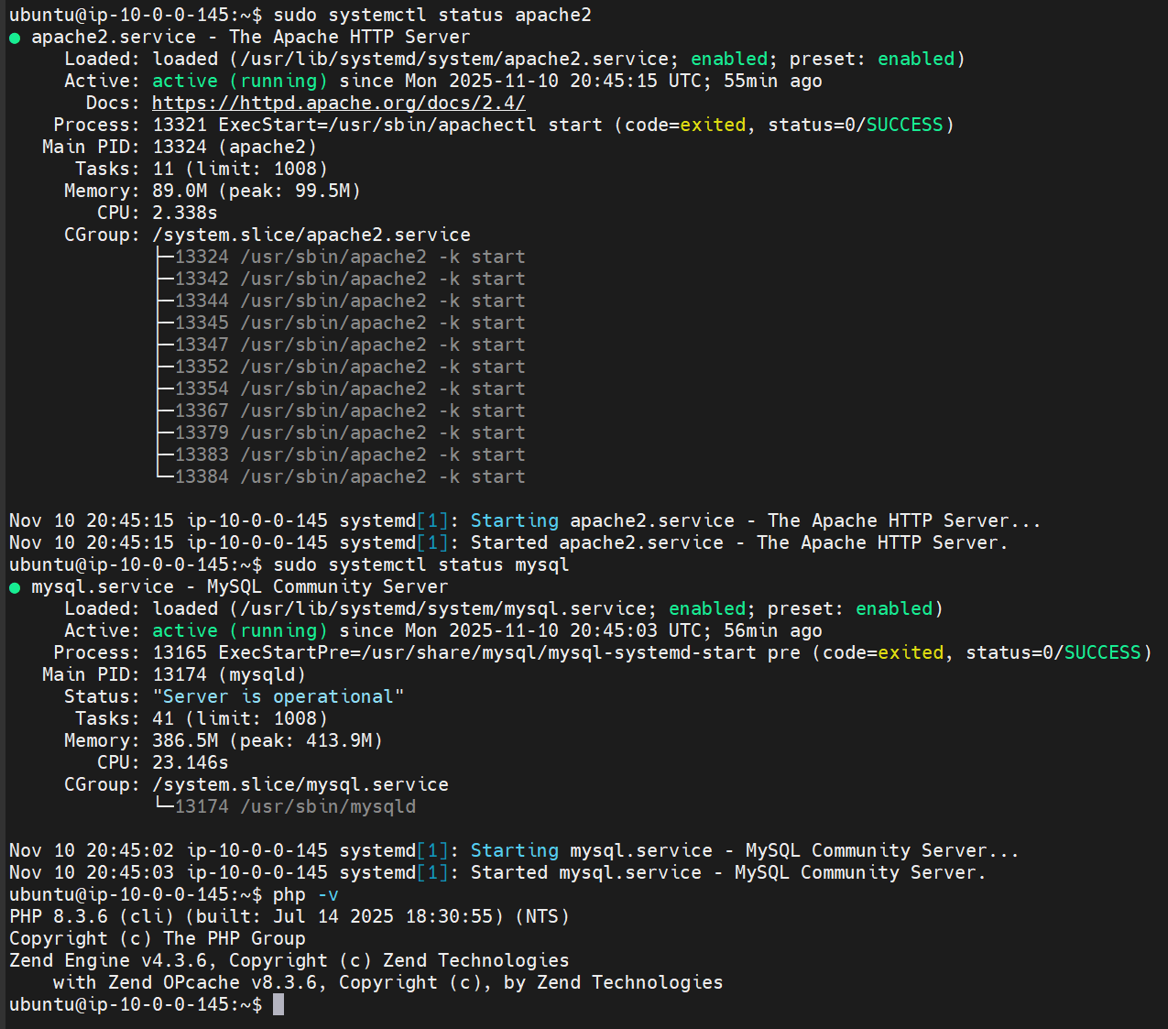
These results confirm that Apache, MySQL, and PHP are installed and the EC2 instance is fully configured to host WordPress.

Step 4: Access and Configure WordPress
Now that the infrastructure and services are operational, access the WordPress setup page in your browser.
To open WordPress setup:
- In browser, go to http://<your-ec2-public-ip>/wp-admin/setup-config.php
- Example: http://34.203.40.26/wp-admin/setup-config.php

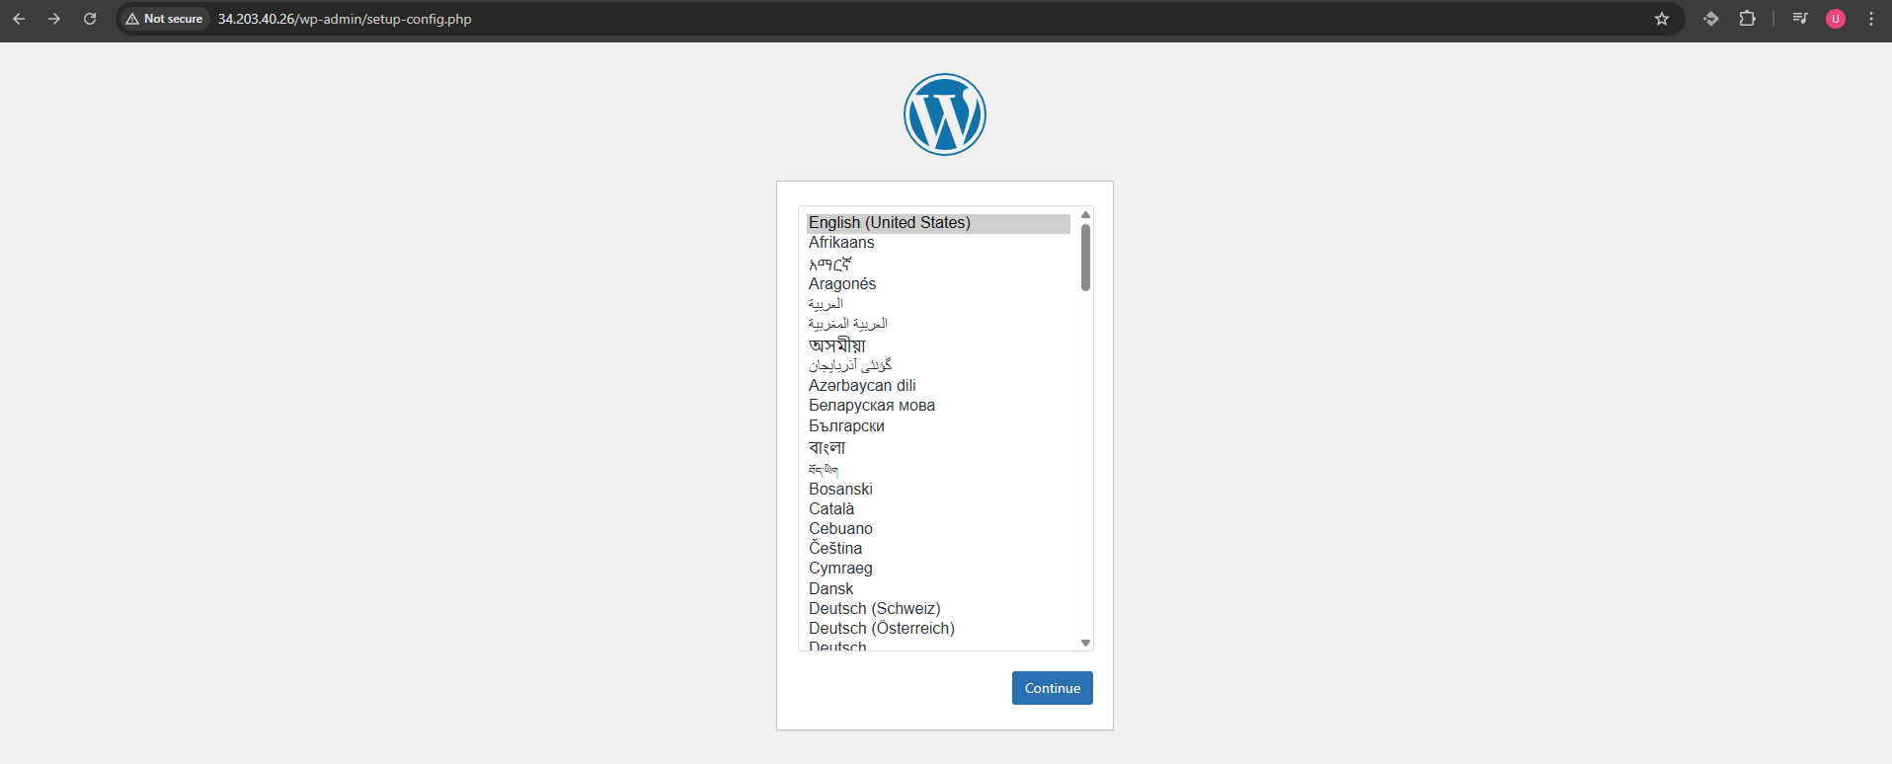

- “Welcome to WordPress” setup screen should display. Select English and click Continue to proceed.
- Click “Let’s go!” button to proceed.

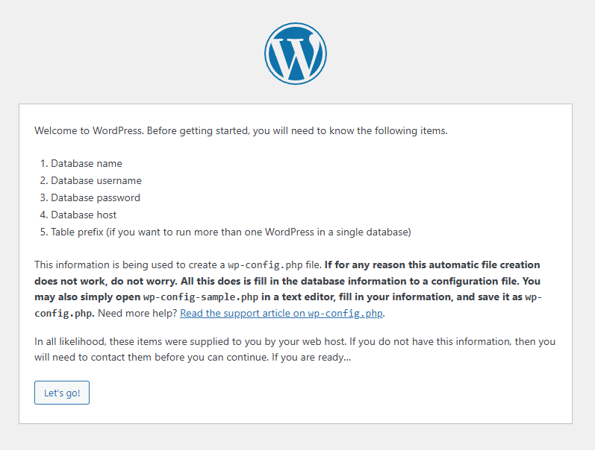

To provide database connection details:
- On the Database Configuration page, enter the following:
  - Database Name: wordpress
  - Username: umarsatti
  - Password: P@ssw0rd
  - Database Host: localhost
  - Table Prefix: _wp
- Click Submit button. If successful, WordPress will confirm that it can connect to the database.
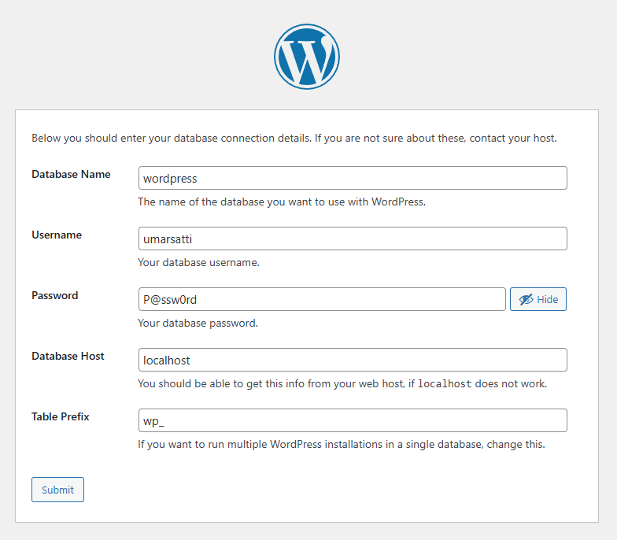
Step 5: Install WordPress
- Once WordPress verifies database connection, it will display the installation page. To complete installation, fill out the required fields:
- Site Title: Umar Satti
- Username: umarsatti
- Password: n*!CxMw@9@#I*qOz6U
- Email: umar@example.com
- Click Install WordPress.
- After a few seconds, a success message is displayed:
  - “Success! WordPress has been installed. Thank you and enjoy!”
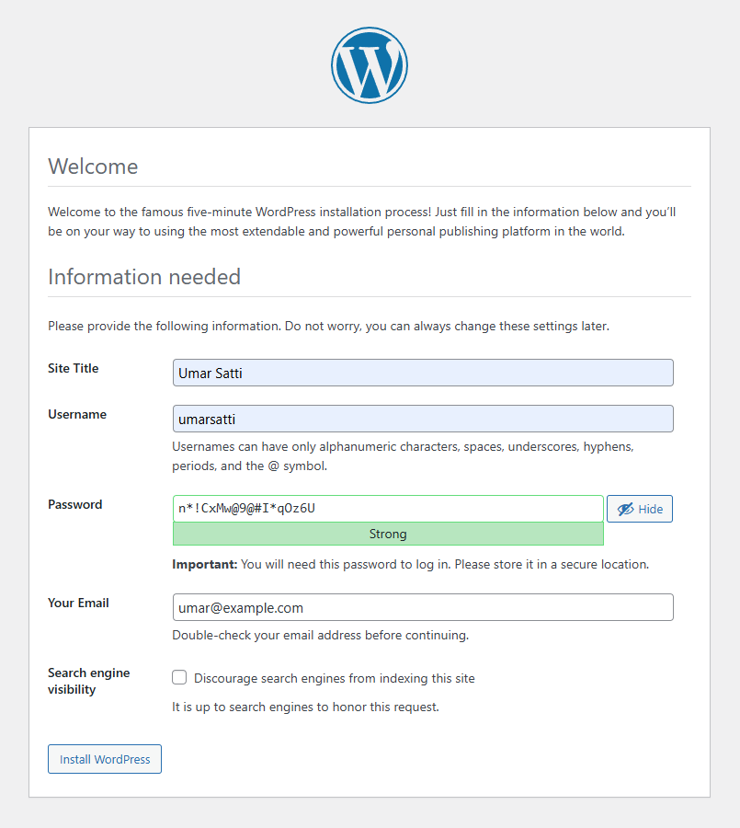
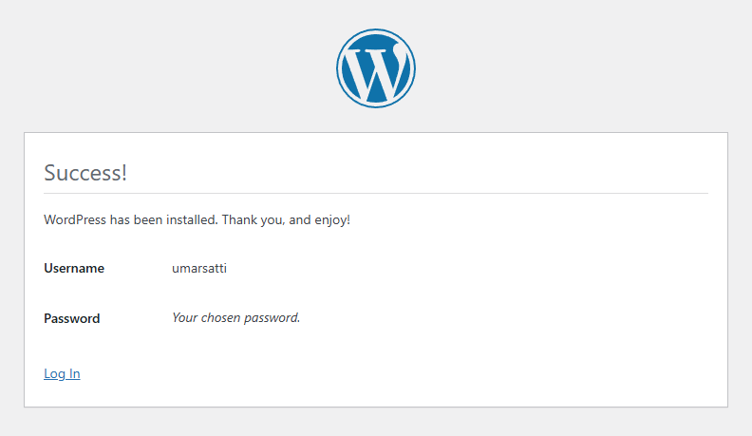

Step 6: Log In to Your WordPress Admin Dashboard
- After installation is completed, click Log In and use the credentials provided earlier.
- Go to http://<your-ec2-public-ip>/wp-login.php
  - Example: http://34.203.40.26/wp-login.php
- Enter the username (umarsatti) and password (P@ssw0rd).
- Click Log In.
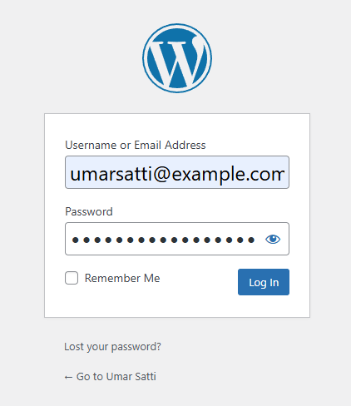

The page should automatically redirect to the WordPress Admin Dashboard, confirming that the website is now fully functional.
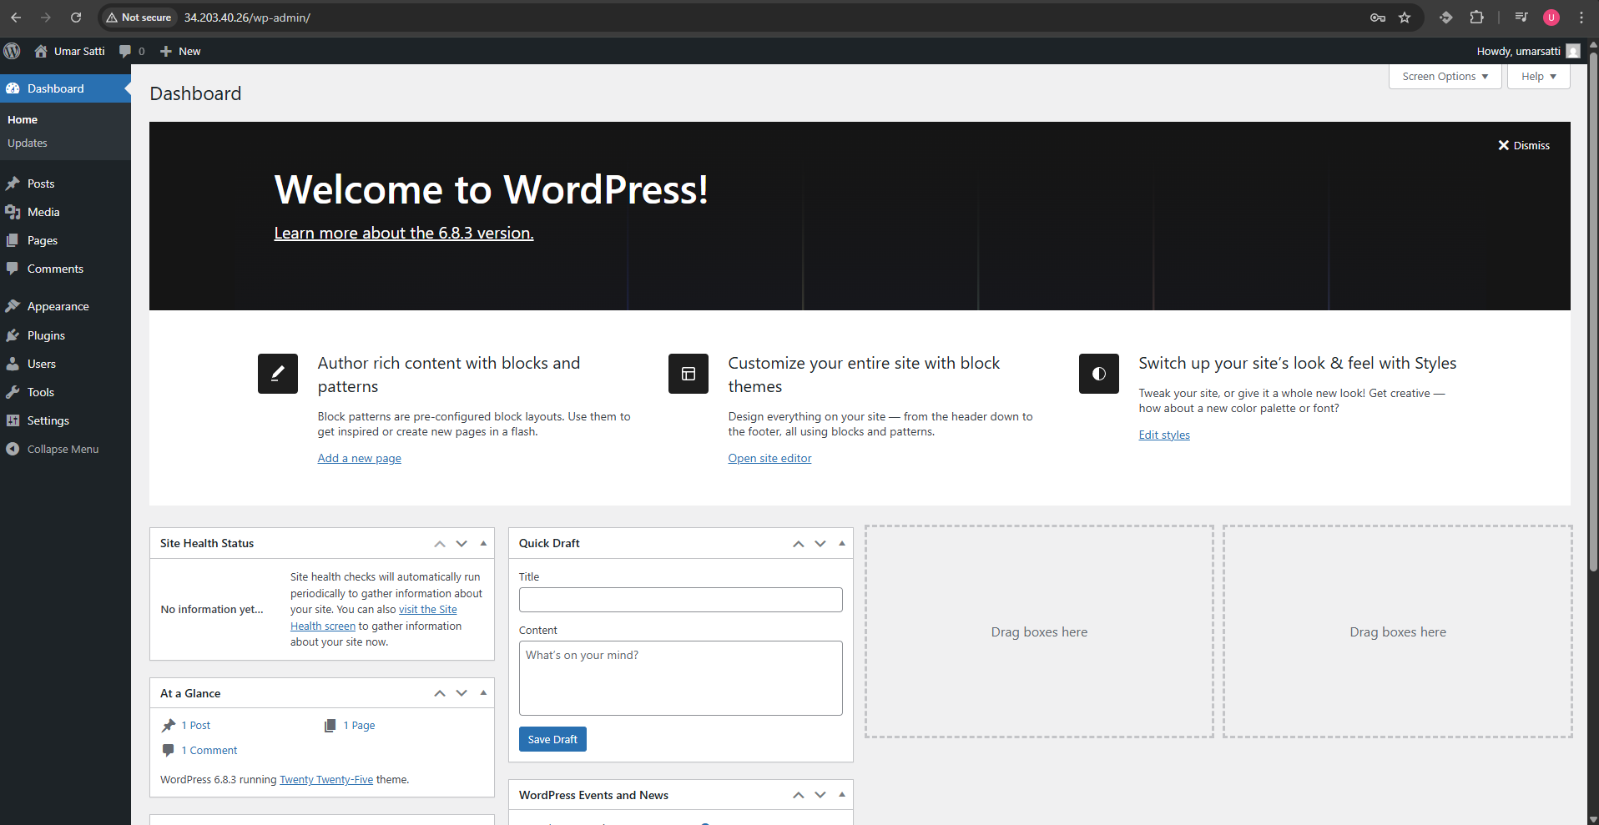

The AWS infrastructure, provisioned by Terraform, is now complete and verified. The deployment and initial configuration of the WordPress application were successful, meaning the application is healthy and accessible. The components defined in Terraform (VPC, EC2, security groups) and the custom user data script integrated smoothly to create a live WordPress environment. This showcases how infrastructure-as-code simplifies complex deployments.

Task 1.10: Troubleshooting and Lessons Learned
During developing and deploying the Terraform-based WordPress environment, several challenges were encountered, particularly around automation, module communication, and non-interactive scripting. This section documents the issues faced, their underlying causes, and the steps taken to resolve them, so that others following this guide can avoid similar pitfalls.

Issue 1: EC2 User Data Script Fails to Execute MySQL Commands
Problem Description:
While running the Terraform deployment, the EC2 instance launched successfully, but the user data script failed to create the MySQL database and user as expected.
The issue occurred because the mysql command normally runs in interactive mode, waiting for manual user input. However, terraform user data scripts execute in a non-interactive shell at instance boot, meaning that any command requiring interaction will hang indefinitely.
Root Cause:
Using commands such as sudo mysql followed by CREATE DATABASE wordpress; caused the script to stall since it opened the MySQL shell without automatically executing any SQL statements.
Solution:
To ensure commands execute non-interactively, I used the mysql -e flag, which allows SQL commands to run directly from the command line. Here is the code:
- mysql -e “CREATE DATABASE wordpress;”
- mysql -e “CREATE USER ‘umarsatti’@’localhost’ IDENTIFIED BY ‘P@ssw0rd’;”
- mysql -e “GRANT ALL PRIVILEGES ON wordpress.* TO ‘umarsatti’@’localhost’;”
- mysql -e “FLUSH PRIVILEGES;”
- mysql -e “EXIT;”
This approach executes SQL statements inline, allowing the EC2 user data script to complete without requiring human input.

Issue 2: Incorrect Implementation of EC2 User Data in Terraform
Problem Description:
Initially, there was confusion about how to properly define and attach a user data script to an EC2 instance in Terraform as it is not clearly defined in Terraform documentation. The script failed to execute or was not recognized, leading to an incomplete WordPress setup.
Root Cause:
User data was not being passed correctly to the aws_instance resource. Terraform requires the script to be provided as a string or a file reference. It cannot automatically interpret arbitrary text blocks unless properly formatted.
Solution
User data scripts should be written as Bash shell scripts (with #!/bin/bash at the top).
To properly link the script to the Terraform EC2 resource, the following syntax should be used within the aws_instance resource:
- user_data = file(“${path.root}/userdata.sh”)
This tells Terraform to read the contents of the external userdata.sh file located in the root module and pass it to the EC2 instance. This method ensures the script is uploaded in the correct format and executed at instance launch. Alternatively, if the user data script is in the same directory as EC2 module, it should have the following syntax:
- user_data = file(“${path.module}/userdata.sh”)

Issue 3: Sharing Outputs Between Terraform Modules
Problem Description:
There was confusion about how to pass values such as subnet IDs and security group IDs from the VPC module to the EC2 module. Terraform modules are isolated by design, so variables defined in one module are not directly accessible in another.
Root Cause:
Terraform modules don’t share variables automatically. To pass data between them, outputs from one module must explicitly be referenced as inputs (input variables) in another module.
Solution:
The solution involved using outputs.tf in the VPC module and referencing those outputs in the EC2 module using variables.

Conclusion
This project successfully demonstrated how to automate infrastructure provisioning and WordPress deployment on AWS using Terraform. By following this documentation, users can create the same setup to launch an EC2 WordPress environment with minimal manual configuration.

